Lab 03 – Worksheet

Name: Abdul Moiz Ahmed | ID: aa08811 | Section: T4

Note: Assumptions and logics should be explained separately in tasks after the task results.

Task 1

Provide appropriately commented codes (Mention question part before each part)
addi x10, x0, 12
addi x11, x0, 12
jal x1, sum # calls the function named sum
addi x11, x10, 0
li x10, 1
ecall
j exit
sum:
add x10, x11, x10
jalr x0, 0(x1)

exit:

Add screenshot of your results (register)
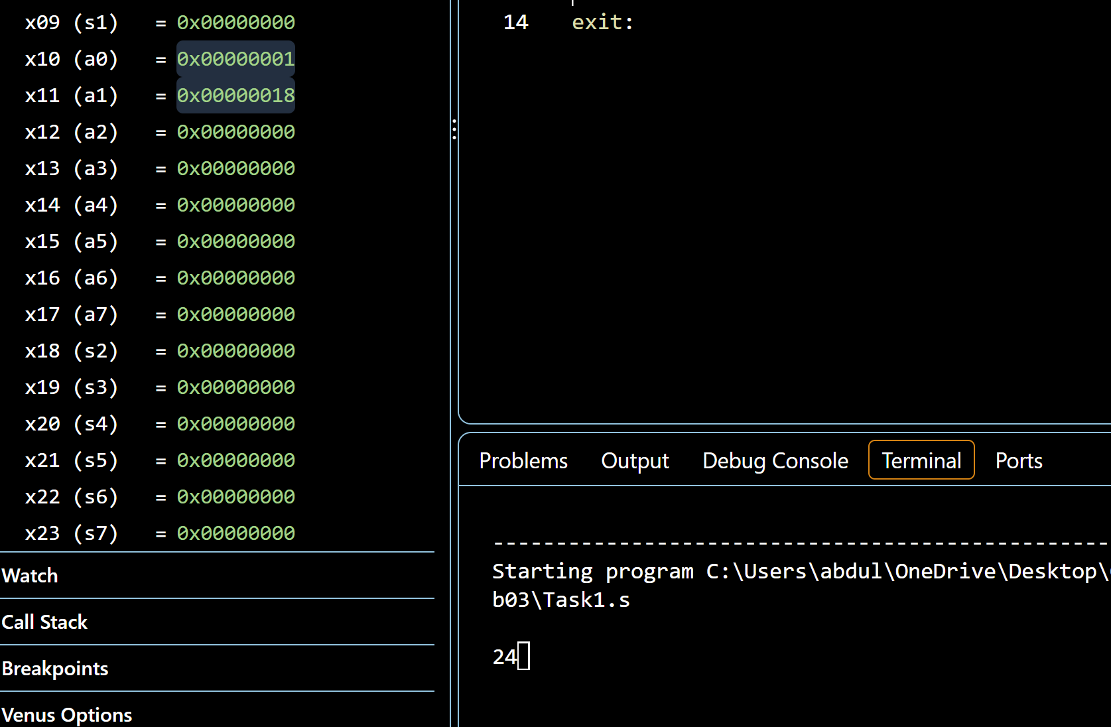

The function adds 12 + 12 and returns 24. The result is stored in x11 and printed as 24 in the terminal

Task 2

Provide appropriately commented codes (Mention question part before each part)
leaf_example:
#we first makespace on stack
addi x2, x2, -12

#registers saved
sw x18, 8(x2)
sw x19, 4(x2)
sw x20, 0(x2)

#g+h
add x18, x10, x11
#i+j
add x19, x12, x13
#f=(g+h)-(i+j)
sub x20, x18, x19

addi x10, x20, 0

lw x20, 0(x2)
lw x19, 4(x2)
lw x18, 8(x2)

#restore stack and return
addi x2, x2, 12
jalr x0, 0(x1)

For testing the code, g = 10, h = 7, i = 4 and j = 2 were used

Add screenshot of your results
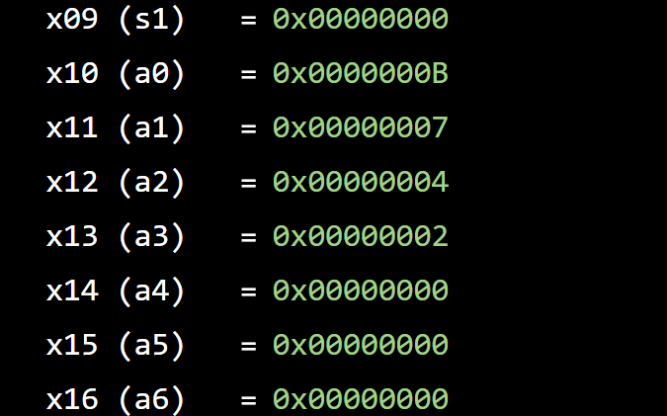

The function calculates (10 + 7) - (4 + 2) = 11 and the returned result is stored in x10

Task 3 Provide appropriately commented codes (Mention question part before each part)
swap:
#find address of v[k]
slli x6, x11, 2
add x6, x10, x6
#load v[k] and v[k+1]
lw x5, 0(x6)
lw x7, 4(x6)
#swap the valeus
sw x7, 0(x6)
sw x5, 4(x6)
#return
jalr x0, 0(x1)

Add screenshots of your results
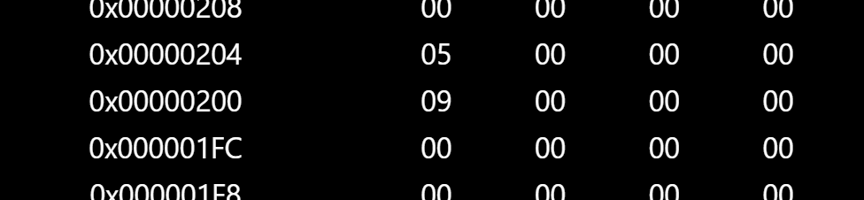

The swap function was able to exchange the two array values and after the swap v[0] = 9 and v[1] = 5

Task 4 Provide appropriately commented codes

strcpy:
#first we mak space on stack and save reg x19
addi x2, x2, -4
sw x19, 0(x2)
#i=0
addi x19, x0, 0
Loop:
#we get address of y[i]
add x5, x11, x19
#load y[i]
lbu x6, 0(x5)
#address x[i]
add x7, x10, x19

#y[i]copied in x[i]
sb x6, 0(x7)
#exit if null
beq x6, x0, Exit

#i+=1
addi x19, x19, 1
beq x0, x0, Loop
Exit:
lw x19, 0(x2)
addi x2, x2, 4
jalr x0, 0(x1)

Add screenshots of your results
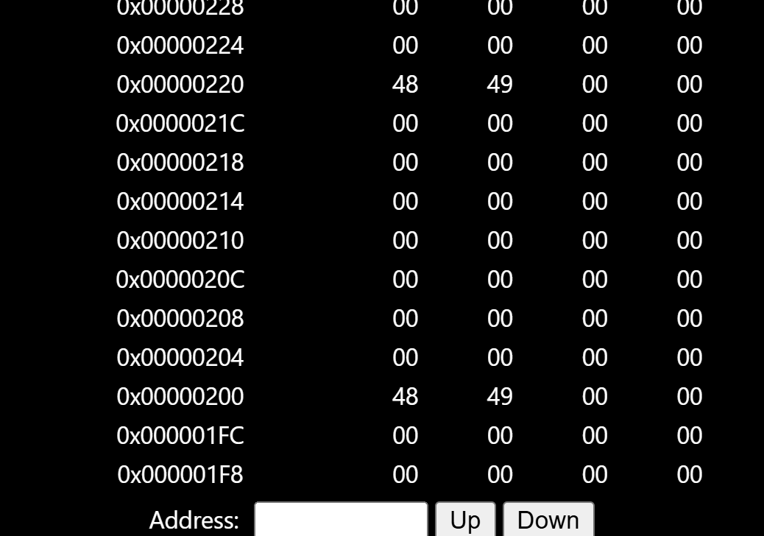

The function copies the string from y to x one byte at a time and the result in memoryshows that both addresses of 0x220 and 0x200 contain 48 49 00 00, which means the string was copied successfully

Lab 03 – Introduction to RISC V Assembly (Jumps and Returns)

Assessment Rubrics

Points Distribution
Task No. | LR2  Code | LR5  Results | AR7  Report  Submission and Git Upload
Task 1 | /10 | /05 | /10 & /10
Task 2 | /10 | /10 | /10 & /10
Task 3 | /10 | /10 | /10 & /10
Task 4 | /15 | /10 | /10 & /10
Total Points | /100 Points
CLO Mapped | CLO 2
For description of different levels of the mapped rubrics, please refer the provided Lab Evaluation Assessment Rubrics and Affective Domain Assessment Rubrics.
# | Assessment Elements | Level 1: Unsatisfactory  Points 0-1 | Level 2: Developing  Points 2 | Level 3:Good  Points 3 | Level 4:Exemplary  Points 4
LR2 | Program/Code/ Simulation Model/ Network Model | Program/code/simulation model/network model does not implement the required functionality and has several errors. The student is not able to utilize even the basic tools of the software. | Program/code/simulation model/network model has some errors and does not produce completely accurate results. Student has limited command on the basic tools of the software. | Program/code/simulation model/network model gives correct output but not efficiently implemented or implemented by computationally complex routine. | Program/code/simulation /network model is efficiently implemented and gives correct output. Student has full command on the basic tools of the software.
LR5 | Results & Plots | Figures/ graphs / tables are not developed or are poorly constructed with erroneous results. Titles, captions, units are not mentioned. Data is presented in an obscure manner. | Figures, graphs and tables are drawn but contain errors. Titles, captions, units are not accurate. Data presentation is not too clear. | All figures, graphs, tables are correctly drawn but contain minor errors or some of the details are missing. | Figures / graphs / tables are correctly drawn and appropriate titles/captions and proper units are mentioned. Data presentation is systematic.
AR9 | Report | All the in-lab tasks are not included in report and / or the report is submitted too late. | Most of the tasks are included in report but are not well explained. All the necessary figures / plots are not included. Report is submitted after due date. | Good summary of most the in-lab tasks is included in report. The work is supported by figures and plots with explanations. The report is submitted timely. | Detailed summary of the in-lab tasks is provided. All tasks are included and explained well. Data is presented clearly including all the necessary figures, plots and tables.

